**data explorer gui walkthrough**

**by Dawnis Chow 10/02/2018**

To start the GUI, type data_explorer_gui into the Matlab command line. If, for some reason, it is not on the Matlab PATH, the GUI is located at

C:/Users/Joe/Dropbox/data_explorer_gui/GUI/data_explorer_gui.m.

**Opening a data set and manipulating ROIs.**

1. Go to menu item Dataset->Load Dataset and navigate to the folder ‘K:/DATA EXPLORATION GUI DEMO’. Select the file called shck2_ls_fluorescence_time_series.mat. After a few moments, the data set should be loaded into the GUI.
2. Try moving and dragging the horizontal slider in the **Navigation Panel** to change the slice in the Coronal Slice Window on the right. Slice thickness can be changed using the text box under ‘Slice Thickness (um)’.
3. Slide the vertical sider on the Coronal Slice Window up and down to change the highlighted cell. You can also click to select neurons. Both plots may be rotated in 3D using the rotation tool. 
4. 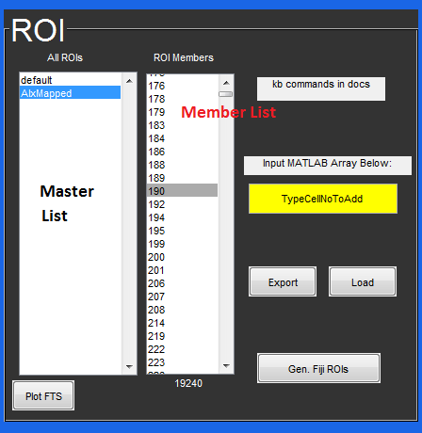Let’s add some ROIs. Go to the ROI Master box (on the left in the ROI panel) and hit ‘a’ on the keyboard. We’ll call our new ROI ‘New1’. Notice that when you select it, the red cells disappear. This is because there are no cells in the ROI member list by default. We will remedy the situation. Type [5:5:80000] into the Input Box in the ROI Panel (yellow) and press enter. Now, if you change the slice (horizontal slider) you will see that every fifth neuron has been added. Try making another ROI called ‘New2’ and type 9 ‘enter’, 4551 ‘enter’, and 309 ‘enter’. You could have also typed [9,4551,309] and then enter as well to add those neurons all at once.

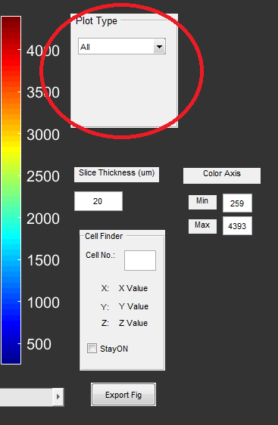

1. Change Plot Type (under Navigation Panel) to ROI. Highlight both ‘New1’ and ‘New2’ using the shift key. You can see where the members of the ROI are located spatially. You can use the 3D rotation tool to rotate the plot. When you are done rotating, left click the mouse and ‘reset to original view’ to reset the plot. De-select the rotation tool.
2. Use the ‘Load’ button and select the AlxROI file. This is a pre-defined ROI that labels Alx+ neurons in the hindbrain. Highlight the ‘Alx’ group for now.
3. Highlight one of the members of the Alx ROI (e.g. 1097). Press ‘f’ to locate that cell in space. You can also type in the number of a cell in the Cell Finder (Navigation Panel) to locate its z-slice and coordinates.

**Visualizing Time Series**

1. Let’s see what some of the traces for Alx neurons look like. Highlight multiple members in the ROI members listbox using shift or ctl. Hit ‘p’ on the keyboard (or ‘q’, or press Plot FTS in the lower left). You can see the activity of these neurons in Time Series and their average in the Mean plot.
2. At the bottom of the Tools panel, select RawHeat to use a heatmap view of raw fluorescence instead. ‘dFF’ won’t work for now unless your data file includes the variable dFF or you use the ‘Compute dFF’ tool.

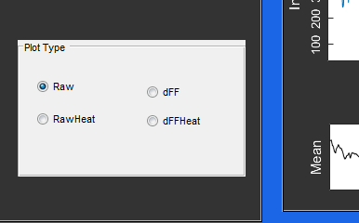

**Generating Time Slice Movies**

1. We want to visualize the raw data through time. To do this, we will generate a .tif file that contains one plane through time using your ‘.klb’ or ‘.tif’ directory.
2. Hit the ‘Generate Time Slice Movies’ button under Tools. Navigate to the ‘stack_files’ directory and hit ‘Select Folder’. The function will let you know every time it has completed a frame. You should see a ‘.tif’ file for every slice in the folder tsView. When the function has finished running, it will create a directory under stack_files called tsView (‘stack_files/tsView’) which contain the processed slice movies.
3. For convenience, I’ve included a few complete ‘tsView.tif’ files under the folder ‘tsViewComplete’ in the parent directory which has all the time points for a few z planes of this data set. We will load one such file now.
4. Hit ‘Load Slice Movie’ under the Tools Panel. Navigate into the tsViewComplete folder and select ts024.tif. This will take about 23 s to load.
5. Once loaded, change the Plot Type (Navigation Panel) to ‘Validation’. Now the horizontal slider controls time.
6. 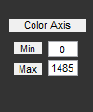Use the ‘Load Z Stack’ button to allow navigation through Z. Open the stack_files folder again and select ‘timeProj/tS_maxproj20170222T210032.tif’. (In general, you will want to use either the max time or mean time projection of your experiment for this step). You can now use the vertical slider to examine z. Change Z to 24 to match the slice movie.
7. Note: You can change the color mapping of plots in any viewing mode by editing the Color Axis tool (to set min and max) and moving any of the sliders to refresh the plots.
8. We want to plot the ROIs onto the left window in the Navigation Pane. To do this, hit the ‘Throw ROIs’ button. This will highlight the neurons that appear in the current z-slice. Moving the horizontal slider will update the plot.

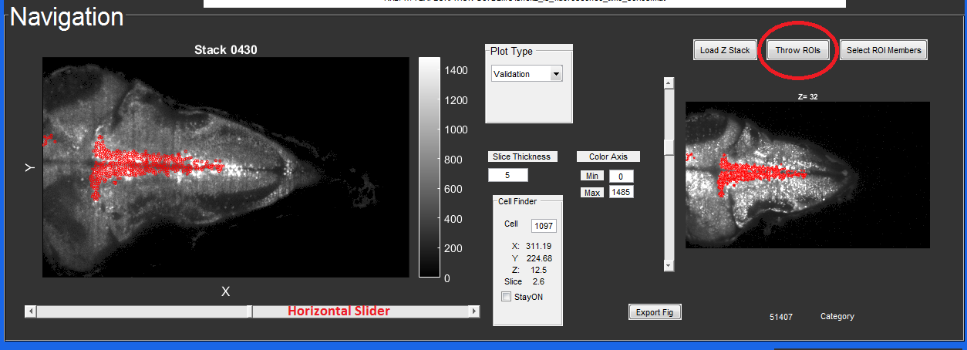

1. You can use the magnifying glass tool to zoom in on any plot to examine the neurons more closely. (I suggest hitting ‘Plot FTS’ and using the RawHeat option to visualize activity).
2. Let’s zoom in on some particular neurons and see their activity. Select the ‘AlxOLD’ ROI in the ROI Master List and navigate to Z=24.
3. Use the magnifying glass tool and draw a rectangle around ~3-5 neurons of interest.
4. Now, hit the ‘Select ROI members’ button and draw a rectangle around just a few neurons. Note that this will only work in the Z-Stack window. Hit the PlotFTS button.
5. Move the horizontal time slider. Only the selected neurons will be plotted on the time slice movie.

**Removing Overlapping Neurons and Saving the Results**

1. To filter out neurons that are too close together, use the Remove Overlaps button under the Tools panel.
2. When the remove overlaps tool appears, input the minimum distance desired for neighbors in the data set. There is a checkbox to limit the algorithm to neighboring slices for each neuron. (This may be used if you are already satisfied with the spacing within each plane.) The default value is 5.4 microns.
3. The tool can take up to 90 s for large data sets. When it is done, you will see two new ROI sets, labeled ‘toKeep’ and ‘toRemove’ so that you can examine which neurons were flagged for removal.
4. To check the algorithm: I recommend zooming into a small area containing ~10 or so neurons (highlighting the All ROI set). Double click on the toRemove ROI to see which neurons are flagged for removal. Move up and down one slice at a time to see which neighbors caused each one to be flagged. You can compare this set to the original by double clicking on ‘All’ under the ROI master list (this takes 1-2 s to plot).
5. To save a new dataset with only neurons in the ‘toKeep’ category, use the Export button under the ROI panel. By default, this will save the ROI information separately. A pop-up dialog will ask whether you want to filter the current data set by the ROIs. Select YES.
6. Load the data associated with ‘toKeep’. You may rename the ‘.mat’ file manually as desired. If you want to avoid saving the other ROIs, use the ‘delete’ function in the ROI Master Listbox (left listbox) before Export.

**Interacting with Imaris**

1. Let’s check our ROI against a volume in Imaris. Make sure that Imaris is open.
2. Load ‘L04Shck2_proj.ims’ in the demo folder into Imaris.
3. In the GUI, go to the menu item Imaris->Connect.
4. Try Imaris->Imaris Visibility. If the connection was successful, this will cause the Imaris window to disappear. Use the keyboard shortcut CTL+V to make it re-appear.
5. Select the ‘AlxOld’ ROI. These are the Alx neurons that are born earlier. Go to menu item Imaris->plotROI to transfer this ROI to Imaris.
6. Let’s manipulate the ROI based on information in the Imaris volume. Hit the AlxOLD spots object in Imaris and then the filter. Add an intensity Mean Ch=1 filter and pick a threshold, then duplicate it to a new spots object (button at the bottom of Imaris).
7. Rename this duplicated object ‘Filtered’.
8. Let’s import this again into our GUI using the menu item Imaris->importROI. Select ‘filtered’ and press OK.